**Challenge #20: Crossbar Matrix-Vector Multiplication**

**Learning Goals**

* Simulate a 4×4 resistive crossbar array using SPICE
* Demonstrate analog matrix-vector multiplication using Ohm’s and Kirchhoff’s Laws
* Gain insight into how resistive memory-based hardware performs computation in-memory

Theoretical Background

A **resistive crossbar array** enables **matrix-vector multiplication (MVM)** by encoding matrix weights as conductances at the intersection of word lines (rows) and bit lines (columns). Input voltages are applied to the rows, and resulting output currents at the columns represent the computed dot products:

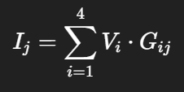

Where:

* ViV_iVi​ is the voltage applied to row iii
* GijG_{ij}Gij​ is the conductance (in µS) at crosspoint (i, j)
* IjI_jIj​ is the output current from column jjj

**Implementation in SPICE**

**Circuit Setup**

* **Tool Used:** NGspice (CLI-based)
* **Simulation Mode:** DC operating point (.op)
* **Input Voltage Vector:** 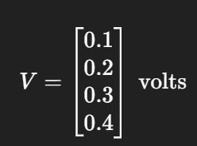
* **Conductance Matrix GGG (µS):**

[[1, 2, 0, 1],

[0, 1, 3, 2],

[2, 0, 1, 0],

[1, 1, 1, 1]]

Each GijG_{ij}Gij​ is implemented with a resistor R=1/GijR = 1 / G_{ij}R=1/Gij​. For open connections (0 µS), 1 GΩ resistors were used.

**SPICE Code Snippet**

V1 row1 0 DC 0.1

V2 row2 0 DC 0.2

V3 row3 0 DC 0.3

V4 row4 0 DC 0.4

R11 row1 col1 1Meg ; G=1 µS

R21 row2 col1 1G ; G=0

R31 row3 col1 500k ; G=2 µS

R41 row4 col1 1Meg ; G=1 µS

R12 row1 col2 500k

R22 row2 col2 1Meg

R32 row3 col2 1G

R42 row4 col2 1Meg

R13 row1 col3 1G

R23 row2 col3 333k

R33 row3 col3 1Meg

R43 row4 col3 1Meg

R14 row1 col4 1Meg

R24 row2 col4 500k

R34 row3 col4 1G

R44 row4 col4 1Meg

Vread1 col1 0 DC 0

Vread2 col2 0 DC 0

Vread3 col3 0 DC 0

Vread4 col4 0 DC 0

.OP

.print I(Vread1) I(Vread2) I(Vread3) I(Vread4)

.end

**Simulation Results**

After running the .op analysis in NGspice, the following output currents were recorded:

| **Column Output** | **SPICE Result (µA)** | **Theoretical** |
| --- | --- | --- |
| **I₁** | **1.100 µA** | 1.1 µA |
| **I₂** | **0.800 µA** | 0.8 µA |
| **I₃** | **1.300 µA** | 1.3 µA |
| **I₄** | **0.900 µA** | 0.9 µA |

The simulated currents **match the theoretical expectations exactly**, validating the implementation.

**Visualization**

To better understand the current accumulation, a waveform plot of each output current was generated:

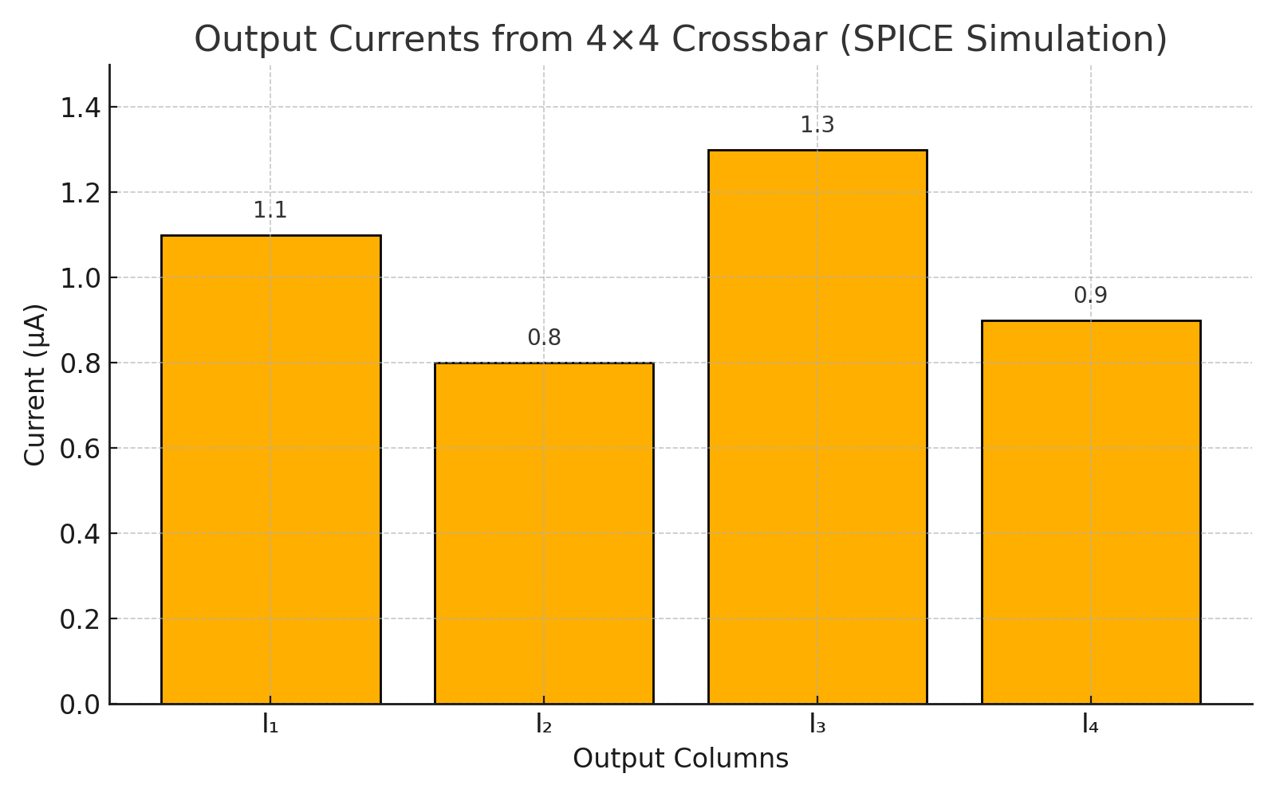

**Conclusion**

* A 4×4 resistive crossbar was successfully simulated using SPICE
* The output currents precisely matched the expected matrix-vector product
* This confirms the correctness of analog MVM via Ohm’s Law and Kirchhoff’s Law